1.1 Purpose:

Our project is a social media application designed to promote outdoor interaction and a community engagement, drawing inspiration from BeReal. Through our platform, users are encouraged to connect with others both on the application and in their home towns. Additionally, the application offers a unique feature where users receive a new prompt every 24 hours which inspires them to explore their surroundings and engage with others.

1.2 Scope:

**Concept:**

This application provides a daily prompt to user, inspiring them to explore their surroundings and connect with their community. Users are encouraged to snap a photo of the prompt’s subject matter and share it with their friends on the platform, fostering a sense of discovery and connection with others. This unique feature, our app offers a fun and interactive way for users to engage with their surroundings and each other on a daily basis.

**Goals & Objectives:**

At MainBuzz, we strive to break down the barriers of digital communication by creating an app that encourages users to step out of their homes and engage with the world around them. Our goal is to foster real-world conversations and facilitate connections between friends and strangers alike, inspiring meaningful and authentic interactions that go beyond the digital realm. With MainBuzz, users can look forward to a more vibrant, engaging, and community-driven social experience.

1.3 Definitions:

* Log-in - Where the user enters their credentials to get to their personalized account
* Home - The main page of MainBuzz where you take a picture
* My Hive - Your friend list
* The Buzz - Your friends' pictures for the day’s topic.
* Settings - The settings page
* Log-out - Used to log the current user out of the app.

2 Specific Requirements:

**Interface:**

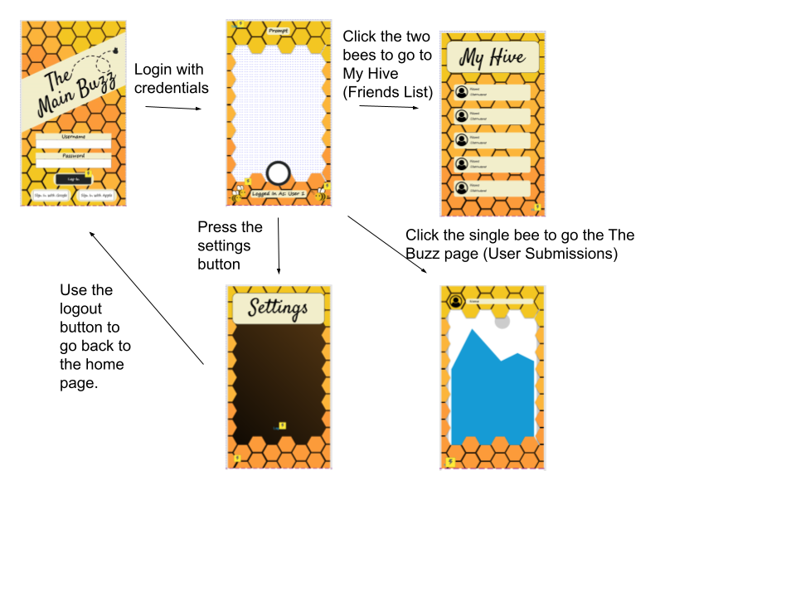

2.2 Functional Requirements:

Login Page

ID: R0.1

Name: Username Text Field

Dependency: None

Description: Where the user enters their username.

ID: R0.2

Name: Password Text Field

Dependency: None

Description: Where the user enters their password.

ID: R0.3

Name: Login Button

Dependency: R0.1 & R0.2

Description: Takes the user to

ID: R0.4

Name: Sign-in with Google

Dependency: None

Description: Takes user to a Google page where they can sign in

ID: R0.5

Name: Sign-in with Apple

Dependency: None

Description: Takes user to an Apple page where they can sign in

Home Page:

ID: R1.1

Name: Settings

Dependency: None

Description: Takes the User to the Settings Page

ID: R1.2

Name: My Hive

Dependency: None

Description: Takes the user to their friends list

ID: R1.3

Name: The Buzz

Dependency: None

Description: Takes the user to their friends posted pictures

My Hive:

ID: R2.1

Name: Home

Dependency: None

Description: Takes the user back to their home page

Settings Page:

ID: R3.1

Name: Log-out

Dependency: None

Description: Logs the user out of the app and takes them to the login page

ID: R3.2

Name: Home

Dependency: None

Description: Takes the user back to their home page

The Buzz Page:

ID: R4.1

Name: Home

Dependency: None

Description: Takes the user back to their home page

ID: 4.2

Name: Next photo

Dependency: None

Description: Takes the user to the next person’s photo